1. ATM Pin

import java.util.Scanner;

public class Main

{

public static void main(String[] args)

{

int n=1234;

int m;

Scanner x=new Scanner(System.in);

m=x.nextInt();

if(n==m)

{

System.out.println("user has access to their account");

}

else

{

System.out.println("enter the pin again");

while(n!=m)

{

Scanner y=new Scanner(System.in);

m=y.nextInt();

if(n==m)

{

System.out.println("user has access to their account");

}

else

{

System.out.println("enter the pin again");

}

}

}

}

}

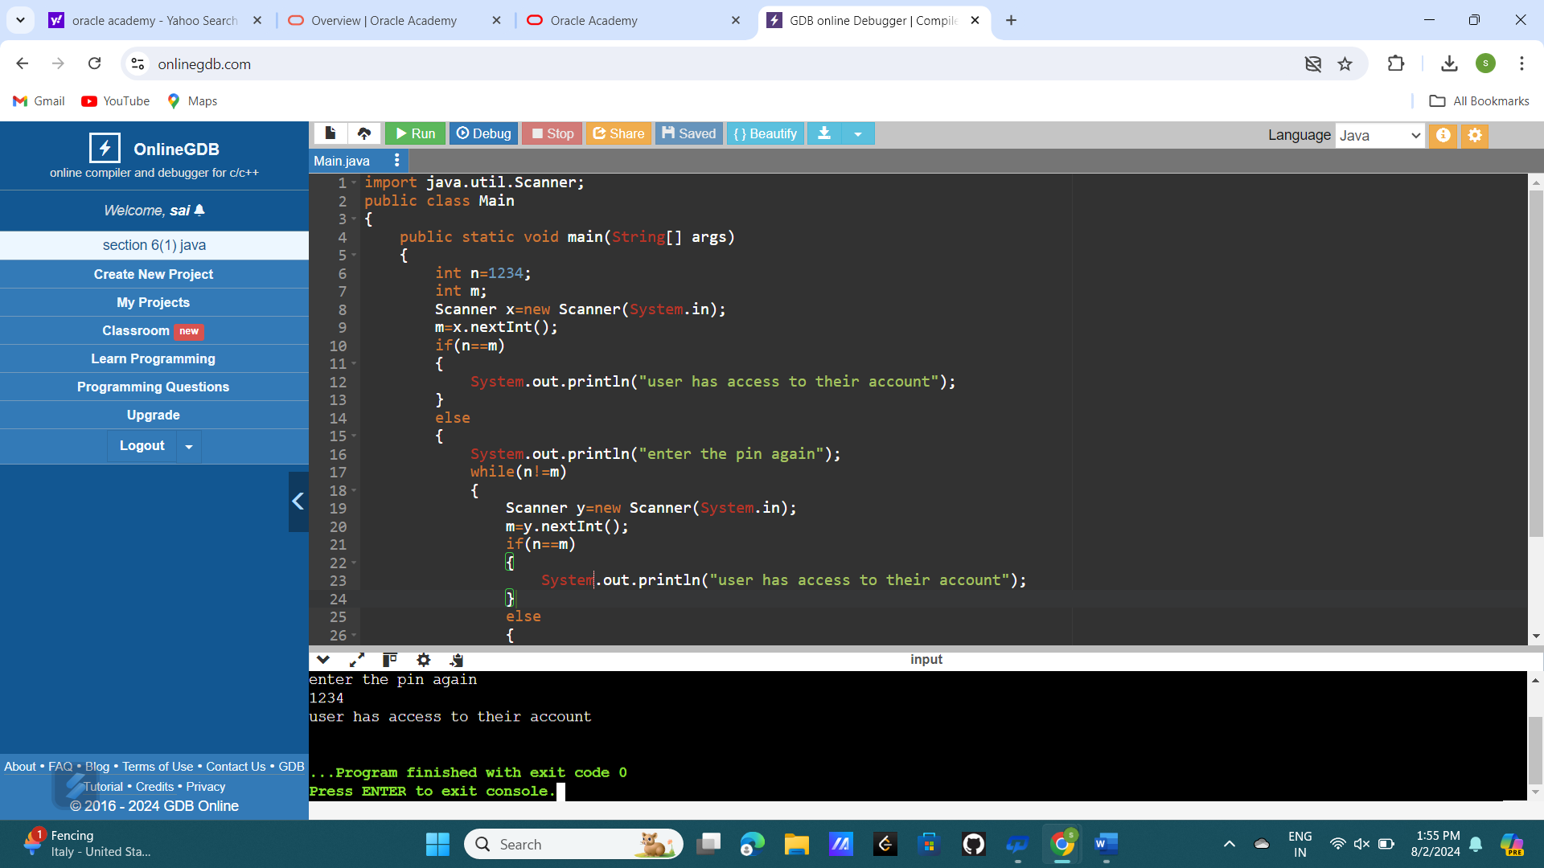

1. MULTIPLES OF A INTEGER:-

import java.util.Scanner;

public class Main

{

public static void main(String[] args)

{

int n;

Scanner x=new Scanner(System.in);

n=x.nextInt();

for(int i=1;i<=12;i++)

{

System.out.println(n+"\*"+i+" = "+(n\*i));

}

}

}

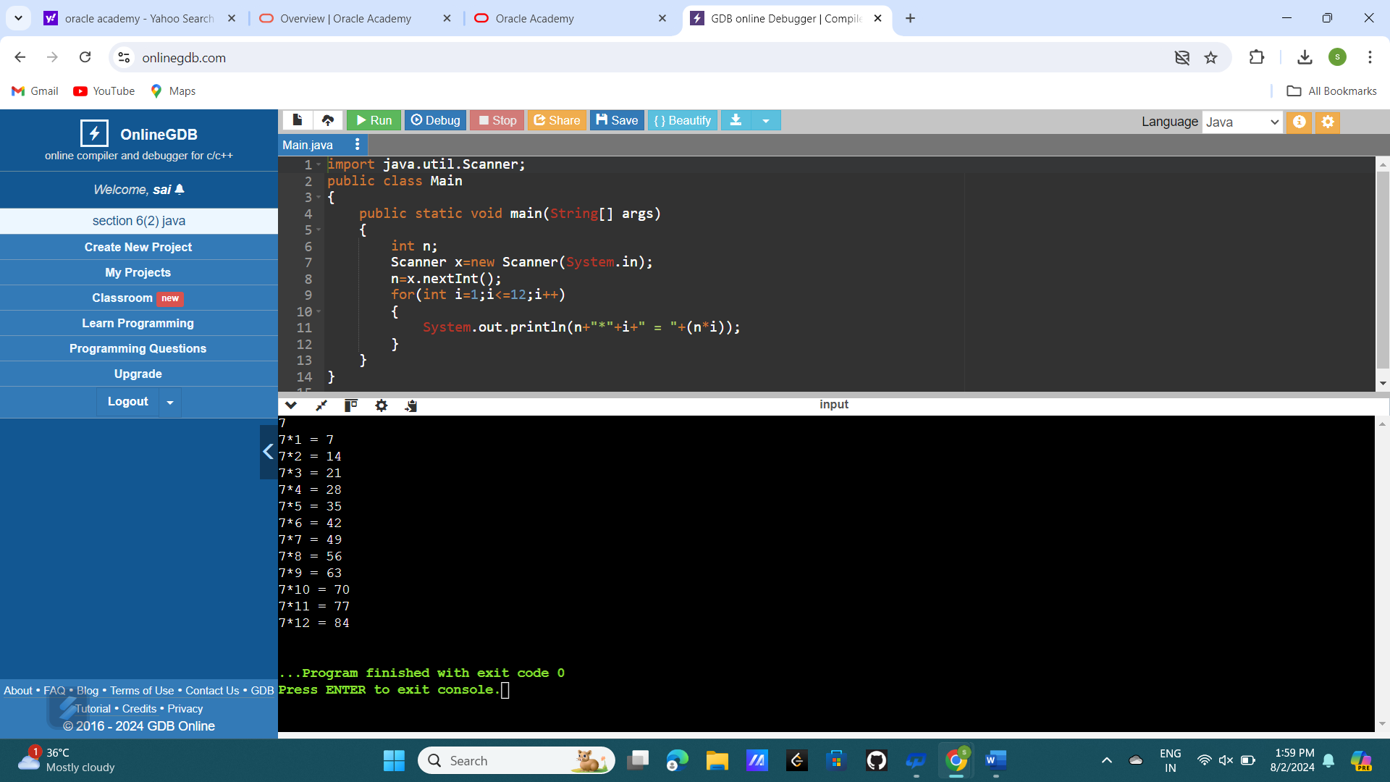

1. (I) HALLOW RECTANGLE:-

public class Main

{

public static void main(String[] args)

{

int n=5,i,j,m=10;

for(i=1;i<=n;i++)

{

for(j=1;j<=m;j++)

{

if(i==1||i==n||j==1||j==m)

{

System.out.print("\* ");

}

else

{

System.out.print(" ");

}

}

System.out.println();

}

}

}

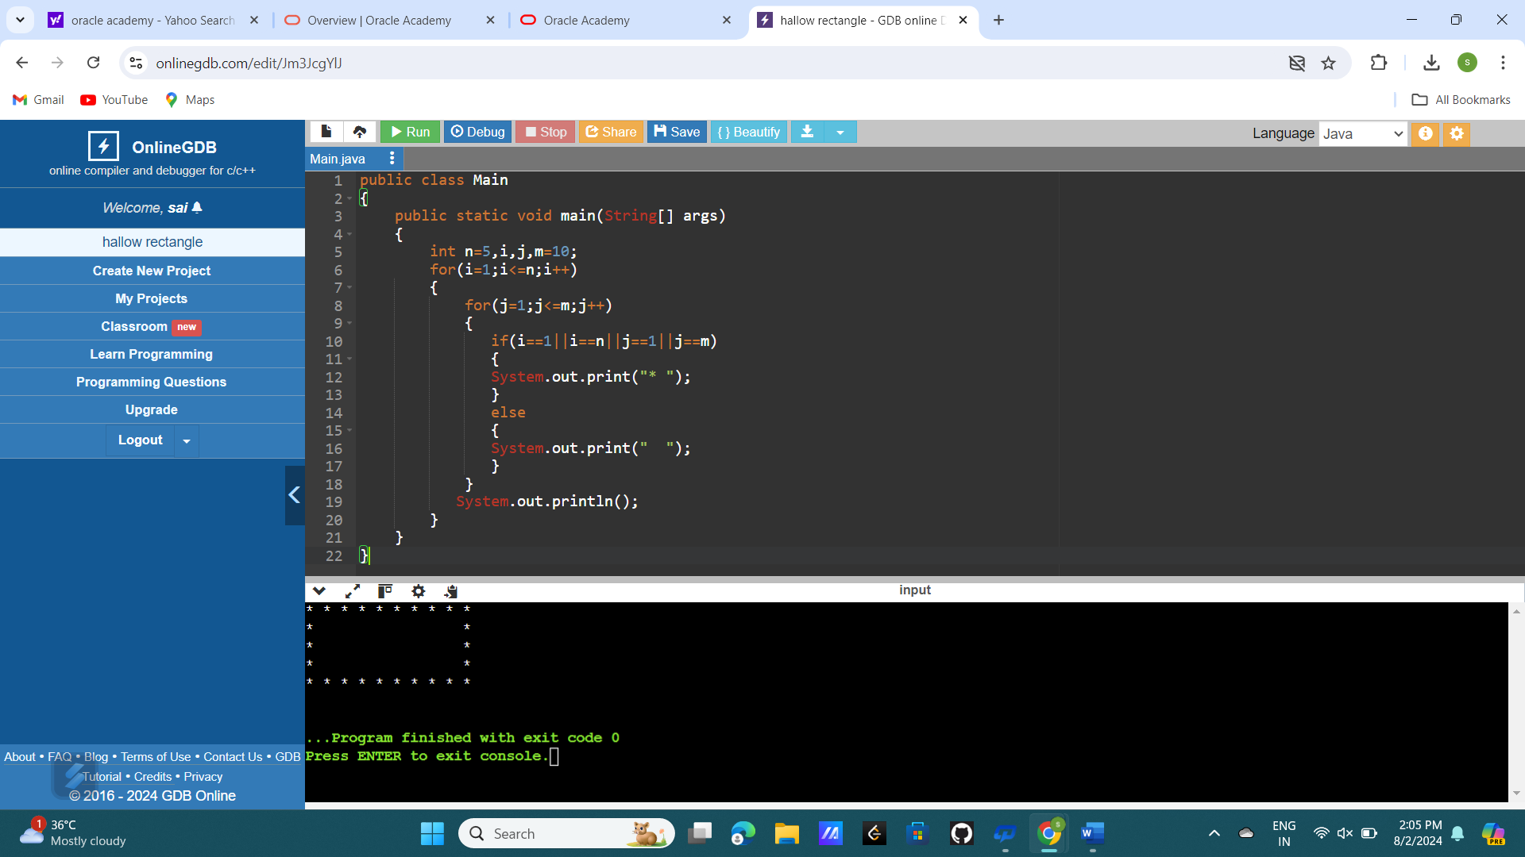

(II) HALLOW RIGHT ANGLED TRIANGLE:-